

Blueprint: board.com

Personal Management Tool

Banerjee, Rishabh

300374594

about.

This website aims to provide users with a comprehensive web application that combines the functionality of a Kanban board, a sticky note app, and a scheduling tool. The goal is to offer a personalized dashboard where users can efficiently manage their tasks, deadlines, and progress. With an emphasis on user-friendly features and customization options, the website aims to streamline productivity and help users achieve their goals effortlessly. Stay tuned for exciting prototypes that will showcase the unique capabilities of this platform.

* Customizable Kanban boards: Create and manage multiple boards with customizable columns to track your tasks and workflow.
* Sticky notes: Add virtual sticky notes to boards or specific tasks for additional details, reminders, or comments.
* Task management: Organize tasks, assign due dates, set priorities, and track progress for effective task management.
* Collaboration: Share boards and tasks with team members or collaborators for seamless collaboration and communication.
* Calendar integration: Sync tasks and deadlines with your calendar for better time management and scheduling.
* Personalized dashboard: Access a personalized dashboard that provides an overview of deadlines, progress, and upcoming tasks.
* Notifications and reminders: Receive notifications and reminders to stay updated on task deadlines and important updates.
* Search and filter: Easily search for tasks, filter by various criteria, and find the information you need quickly.
* Data visualization: Utilize charts or visual representations to analyze task progress, productivity, and team performance.
* User profiles: Create user profiles to manage preferences, access settings, and view activity history.
* Mobile responsiveness: Enjoy a seamless user experience across different devices, including desktop, tablets, and smartphones.

screens.

Dashboard

The Dashboard screen serves as the main hub of the application. It provides an overview of tasks, deadlines, and progress. The screen may include widgets or modules displaying task statistics, upcoming deadlines, and a summary of completed tasks. Users can customize the dashboard to prioritize information that matters to them the most.

Features:

* Task summary and statistics
* Upcoming deadlines
* Progress indicators
* Customizable widgets or modules
* Quick access to important sections/screens

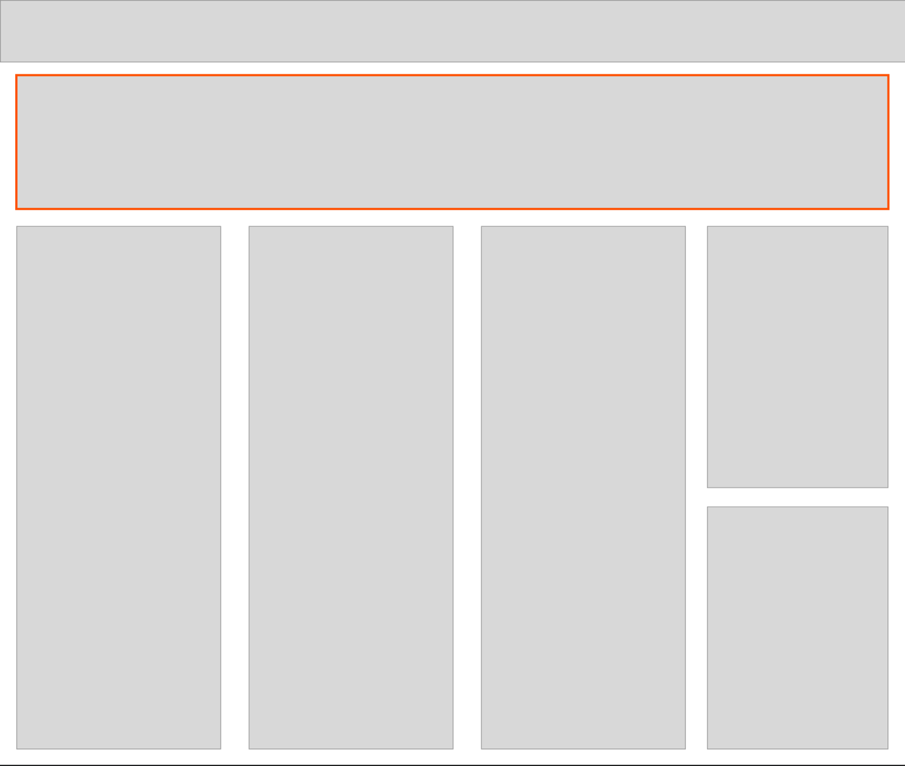

Stickies

The Sticky Note screen provides a space for users to create and manage virtual sticky notes. Users can jot down ideas, reminders, or important details related to their tasks. Sticky notes can be organized, edited, and linked to specific tasks or boards.

Features:

* Creation and editing of virtual sticky notes.
* Customizable colors and sizes for sticky notes
* Ability to attach sticky notes to specific tasks or boards.
* Organization and categorization options
* Quick access and visibility within the application

The Scheduling screen offers a calendar view where users can schedule and track their tasks, deadlines, and events. It provides a visual representation of time slots, allowing users to manage their schedules efficiently. Users can set due dates, reminders, and recurring events.

Features:

* Calendar view with day, week, and month options
* Ability to schedule tasks, deadlines, and events.
* Setting due dates and reminders
* Recurring event options (daily, weekly, monthly)
* A collage of photos

  Description automatically generatedIntegration with other screens, such as Kanban Board or Sticky Note screens

questions? – answered.

1. Can I save and manage events or tasks on the platform? - Yes
2. How customizable are the Kanban boards? Can I add columns or change their names to fit my workflow? - No
3. Does the platform support adding virtual sticky notes to tasks or boards for additional details or comments? - Yes
4. Can I assign due dates and set priorities for tasks? How does the platform help with task management? - Yes
5. Is there a collaboration feature that allows me to share boards or tasks with team members or collaborators? - Yes
6. Does the website integrate with calendars, so I can sync tasks and deadlines for better time management? - No
7. Can I access a personalized dashboard that provides an overview of deadlines, progress, and upcoming tasks? - Yes
8. Will I receive notifications and reminders to stay updated on task deadlines and important updates? - Yes
9. How easy is it to search for tasks or filter them based on criteria such as priority or due date? - Yes
10. Are there any data visualization features that help me analyze task progress, productivity, or team performance? - Yes
11. Can I create user profiles to manage my preferences, access settings, and view my activity history? - No
12. Is the website mobile-responsive, allowing me to access and manage tasks from my smartphone or tablet? - Yes

coming soon…

In conclusion, our web application offers a powerful and unique solution that combines the functionality of a Kanban board, a sticky note app, and a scheduling tool, all within a personalized dashboard. Here are a few reasons why this product is unique and bound to capture everyone's attention:

1. Seamless Integration: By seamlessly integrating the features of a Kanban board, sticky note app, and scheduling tool, our platform offers a comprehensive and all-in-one solution for task management and productivity. Users can streamline their workflow and stay organized without the need for multiple separate tools.
2. Customization and Flexibility: Our product stands out with its high level of customization and flexibility. Users can tailor their boards, columns, and tasks according to their specific workflow and preferences. This adaptability ensures that the platform can cater to a wide range of industries and individual needs.
3. Personalized Dashboard: The personalized dashboard provides a centralized hub for managing tasks, deadlines, and progress. It offers a holistic view of important information and enables users to track their goals effectively. With data visualization and clear insights, users can make informed decisions and optimize their productivity.
4. Collaborative Environment: The collaborative features allow users to easily share boards and tasks with team members or collaborators, enhancing teamwork and communication. This fosters a collaborative environment where users can work together seamlessly and efficiently.
5. Innovative Prototyping: Our upcoming prototypes will showcase the cutting-edge capabilities of the product, highlighting its unique features and user-friendly interface. These prototypes will demonstrate the exceptional user experience and the value our product brings to individuals and teams.

With its seamless integration, customization options, personalized dashboard, collaboration features, and innovative prototypes, our web application is set to capture the attention of users who seek an all-in-one solution for task management, productivity, and effective collaboration.